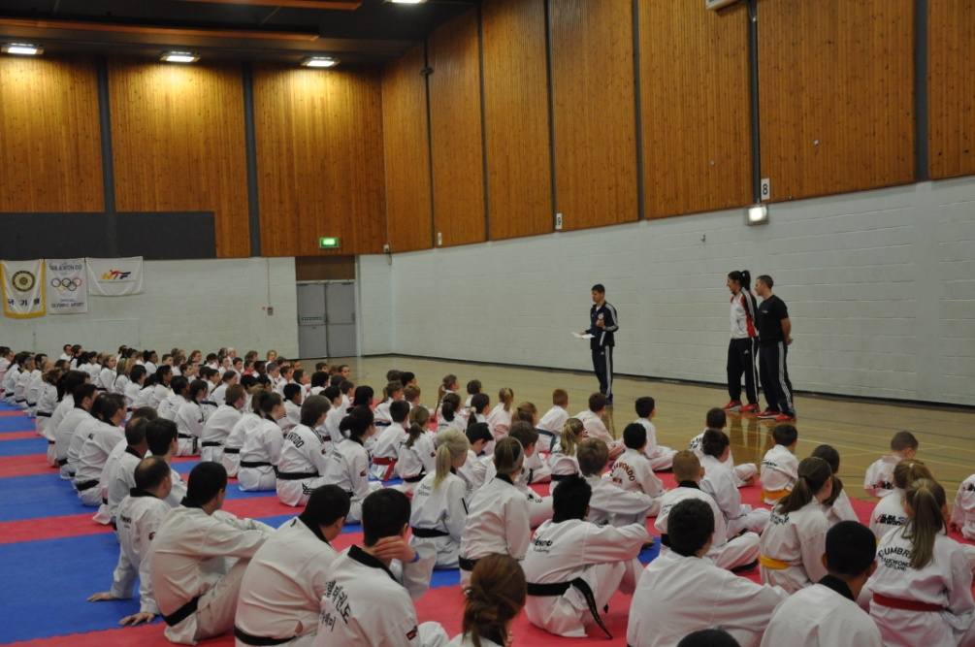

On Saturday 16 February 2013, Taekwondo Scotland hosted the biggest Taekwondo event ever to take place in Scotland.

More than 180 Taekwondo practitioners turned up to take part in a seminar led by World Champion and Olympian Sarah Stevenson MBE. The seminar, arranged and hosted by Chief Instructor of Central Taekwondo Academy, Master David Bailey was thoroughly enjoyed by all.

David Bailey said: "There was a lot of excitement leading up to the event, so I was quietly confident it would go well but for over 180 people, from clubs across Scotland, to turn up to take part and another 100 people on top of that watching, it was just staggering. The atmosphere was fantastic full of excitement and fun!"

Commenting on the seminar, Sarah said: "The seminar was the biggest and best I have ever done. Everyone who was there was so respectful and well behaved – listening and giving their all, joining in. The people made it lots of fun and so easy – I really enjoyed it.!

Following the London Olympics Sarah is spearheading an online fitness programme called The Fitness Project – an exercise and healthy living project that is free to subscribe to. Sarah treated the group to one of her routines which was enjoyed by all. Sarah commented: "I decided to include this as it is a bit of fun that would break up the day. It was still relevant though, as athletes can use it for their conditioning and parents for their fitness, for example. Everyone got involved, including the parents and coaches so that was great!"

The day didn't finish there. Our National Team Development Squad – lead by Performance Coach, Master Nikos Jakubiak, were treated to Sarah as their guest host. Nikos said: "It was fantastic for our players to have this opportunity. It is not often, as a developing player that you get the chance to train with a World Champion and Olympian – passing on her knowledge and experience first hand! We were all really looking forward to it and it didn't disappoint."

Sarah said: "I knew because of the hard working ethic and discipline everyone had from the morning session, that this session was going to be full of determined athletes who want to learn and better themselves – so again it made it really easy to teach and enjoyable too. Hopefully every one of the players [and the participants from the morning] learned something new that they can use."

It didn't stop there….. The day was capped off by Taekwondo Scotland's Annual Dinner Awards Event. Now in its second year, the awards recognise our outstanding players and those who have stood out over the previous 12 months. The evening was enjoyed by our players and their families, with good food, good speeches and a good old Ceilidh!

Nikos said: "On top of a day of training Sarah gave an after dinner speech which was both emotional and inspiring. Her messages were very poignant and echo the culture and ethos we instil in our players."

Summing up the dinner and day Sarah said: "The day overall showed how well Taekwondo Scotland work with each other – all the clubs coming together and interacting like one big team – not discriminating between clubs – but at the same time being proud of what club they come from.

"I was really tired after the speech in particular, as it is emotional. But after a short rest Coach Nikos took me up to the dance floor and I never sat down – it was the hardest I worked all day!

"I had a great day full of fun – I want to be part of Team Scotland!"

Nikos comments: "What can I say – it was a day full of fun learning and togetherness. I just want to finish by saying we have achieved a lot in the last 12 months and indeed since the beginning of the performance programme. All the best to our Poomse performers and Kyorugi athletes – let's enjoy another successful year and we look forward to next year's celebrations!"

You can follow Taekwondo Scotland's news on Facebook (Taekwondo Scotland and Sport Taekwondo Scotland) and on Twitter @Scotland_tkd .

If you want to get involved in Taekwondo or are already involved and would like to find out more about our development and elite programmes please email: sport@taekwondoscotland.org

